**37. ALV_GRID_DISPLAY** Output

Below is the Selection screen .Give a suitable CARRID and Execute.

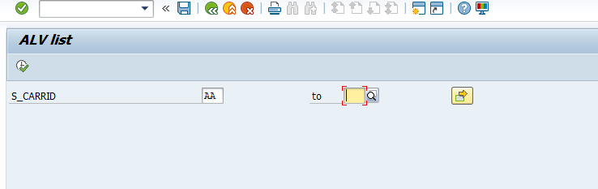

The expected output is as follows

